**TUTORIAL 5 - JSP**

You have been given an HTML file called **Popcorn Sales.html** which creates an HTML form to collect popcorn orders from customers. See **figure 1**.

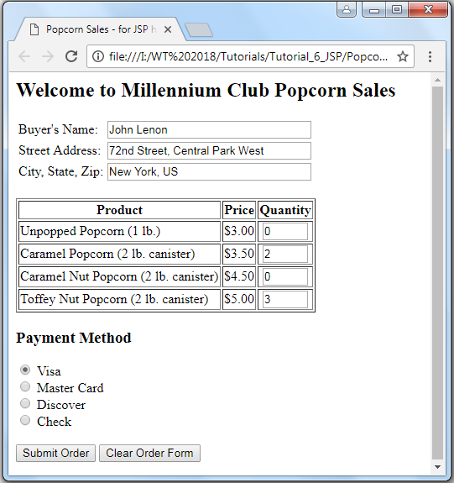

**Figure 1:Popcorn Sales. html**

Your task is to embed PHP script to process the form data and display the order details. The processed form data should look as shown in **figure 2**.

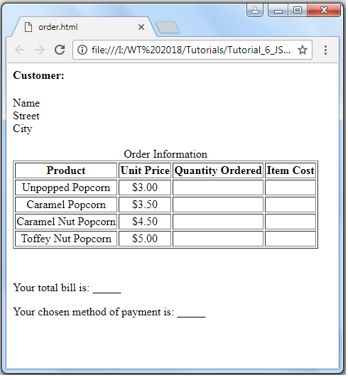

**Figure 2: popcorn2.php**